ARCHITECTURE

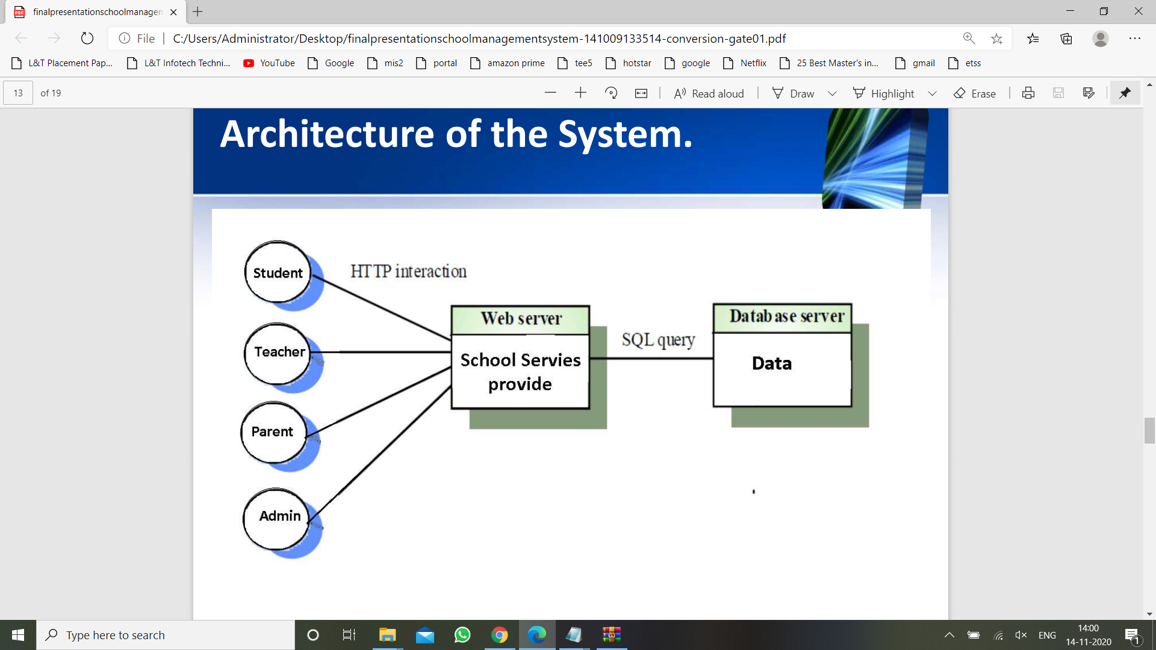

Architecture of “School Billing System”.